

Mini Project Report - 01

Master of Computer Application – General Semester – I

Sub: Front-End Frameworks And Technologies

Topic: RESUME
By Name: Punith M
Reg no.: PROV/ASAC/MCA/7/25/082

Faculty Name: VEERA RAGHAV K

Faculty Signature: _______________

Department of Computer Application
Alliance University
Chandapura - Anekal Main Road, Anekal
Bengaluru - 562 106
September 2025

LIST OF TABLES

FIG NO | NAME OF TABLE | PG NO
1 | INTRODUCTION | 1
2 | INPUT CODE | 2-4
3 | OUTPUT CODE | 5
4 | CONCLUSION | 6

INTRODUCTION

This resume has been designed to highlight the academic qualifications, technical skills, and project experience of students. It has been created using HTML and CSS to demonstrate both web development knowledge and professional presentation skills. The resume provides a concise summary of career objectives, educational background, and technical competencies, along with achievements such as projects and certifications.
The purpose of this resume is to present a clear and professional profile suitable for job applications, internships, and academic submissions, while also showcasing fundamental skills in webpage design and digital formatting.
The resume outlines of educational journey, starting from SSLC up to MCA, reflecting consistent academic performance and growth. It also highlights technical expertise in HTML, CSS, JavaScript, Python, and C, which are essential for careers in software development and web technologies.
The Projects section showcases practical applications of knowledge, such as developing websites and task management systems, while the Certificates section demonstrates continuous learning through online platforms like Coursera, edX, and Udemy.
Overall, this resume serves as a comprehensive representation of academic background, technical knowledge, and career aspirations, making it a valuable professional document for future opportunities

INPUT CODE

<html>
<head>
<title> </title>
<link rel="icon" href="./fruit.jpg">
<style> h1{text-align: center;} div{
border: 1px solid rgb(164, 119, 119);
} h3{ padding-left: 10px;
} h2{ padding-left: 10px;
} p{ padding-left: 10px;
} span{ color: blue;
} li{
padding-bottom: 10px;
}
</style>
</head>
<body>
<div>
<h1>RESUME</h1><hr>
<h3>Name:<span>Punith m</span></h3>
<h3>Email:<span>punith412@gmail.com</span></h3>
<h3>phn:<span>+918095526415</span></h3><hr>

<h2><u>About Me:</u></h2>
<p>To be a part of an organization where get a chance to use my knowledge and skills to contribute in the progress of the organization as well as myself.</p><hr>
<h2><u>Educational Qualifications:</u></h2>
<p>BCA(Banglore University)2025</p>
<p>Department of pre university 2022</p>
<P>SSLC(Karnataka secondary Education Examination board)2020</P><hr>

<h2><u>Technical Skills:</u></h2>
<ul>
<li>HTML</li>
<li>PYTHON</li>
<li>JAVA</li>
<li>C</li>
<li>C++</li>
</ul><hr>

<h2><u>Project:</u></h2>
<ul>
<li>credit score prediction using ml</li>
</ul><hr>
<h2><u>Certifications:</u></h2>
<ul>
<li>Data science</li>
</ul><hr>

<p>Date:____</p>
<p>Place:____</p>

</body>
</html>

OUTPUT CODE
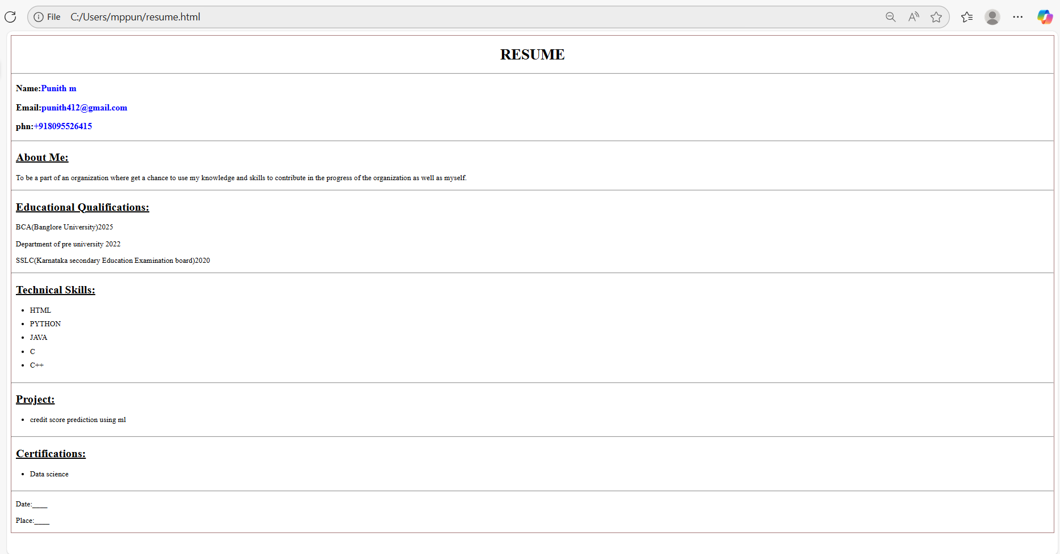

CONCLUSION
The resume provides a structured and comprehensive overview of my academic knowledge, technical skills, and passion for learning . It demonstrates not only my knowledge in programming and web development but also my commitment to continuous learning through projects and certifications. Designed using HTML and CSS, this resume also reflects practical skills in webpage creation and digital presentation, making it suitable for both professional and academic purposes. Overall, the resume highlights as a motivated, skilled, and career-oriented individual, well-prepared to contribute effectively in the field of computer applications and software development.

